**Project Design Phase-II**

**Technology Stack (Architecture & Stack)**

|  |  |
| --- | --- |
| Date | 05 October 2022 |
| Team ID | PNT2022TMID31903 |
| Project Name | Project-Analytics for Hospitals Health-Care Data |
| Maximum Marks | 4 Marks |

**Technical Architecture:**

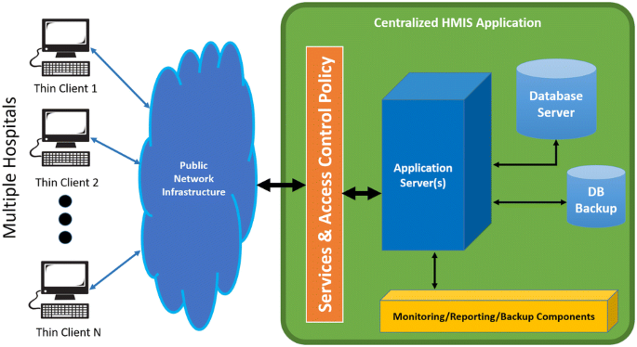

**Table-1 : Components & Technologies:**

|  |  |  |  |
| --- | --- | --- | --- |
| **S.No** | **Component** | **Description** | **Technology** |
| 1. | User Interface | The user interacts with application using Web UI | HTML, CSS, JavaScript |
| 2. | Data Processing | The data from the dataset is pre-processed | IBM Cognos Analytics |
| 3. | Cloud Database | The clean dataset is stored on IBM Cloud | IBM Cloud |
| 4. | Data visualization | The data is visualized into different forms | The data is visualized into different forms |
| 5. | Prediction | These Algorithm techniques are used to predict  the proper way to make the stock in store. | ML algorithms –Logistic Regression,  Linear Regression, Random  Forest,ABC Techniques. |

**Table-2: Application Characteristics:**

|  |  |  |  |
| --- | --- | --- | --- |
| **S.No** | **Characteristics** | **Description** | **Technology** |
| 1. | Open-Source Frameworks | Open-source frameworks used | IBM Cognos Analytics, Python |
| 2. | Security Implementations | Request authentication using Encryptions | Encryptions |
| 3. | Scalable Architecture | Scalability consists of 3-tiers | Web Server – HTML,CSS,Javascript  Application Server – Python  Database Server – IBM Cloud |
| 4. | Availability | The application is available for cloud users | IBM Cloud Hosting |
| 5. | Performance | The user can know how to maintain the  inventory to increase profits. | ML algorithms. |